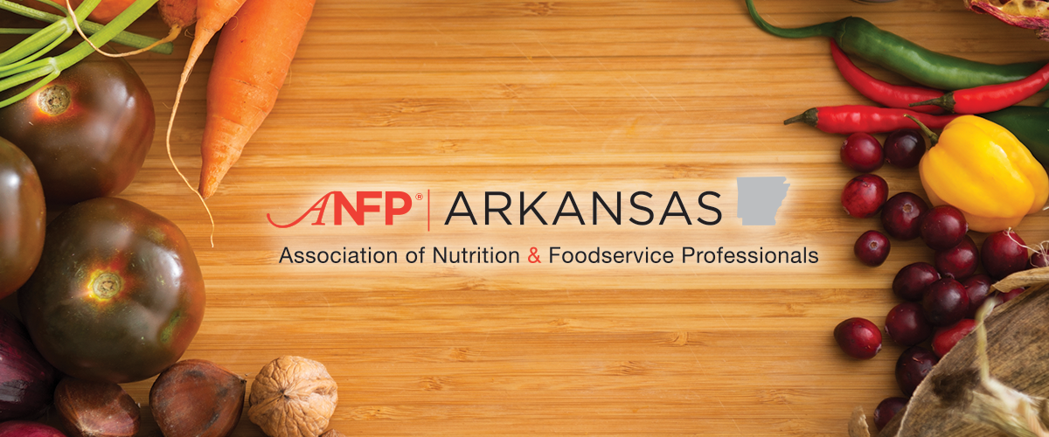
SAVE THE DATE
September 12th and 13th
Hot Springs Convention Center
134 Convention Blvd. Hot Springs, AR. 71901
Hello All,
I am Lynn Nail Chapter President Arkansas Association of Nutrition & Foodservice Professionals.
I am reaching out to inform you Fall Meeting in Hot Springs for the 12th and the 13th^{th} of September at the Hot Springs Convention Center has been scheduled.
Food Expo on the 12th from 12:00 pm-2:00 pm
Bingo that evening!
I am so looking forward to seeing you all again, meeting all our new Certified Dietary Managers and our students.

See You in the Fall,
Lynn Nail, CDM, CFPP
President ANFP ARKANSAS
Please call or text me with any questions 501-400-3862 please leave a message if I do not answer.

