**VOLUME 6, ISSUE 6**

**May 2018**



The Georgia Thrasher

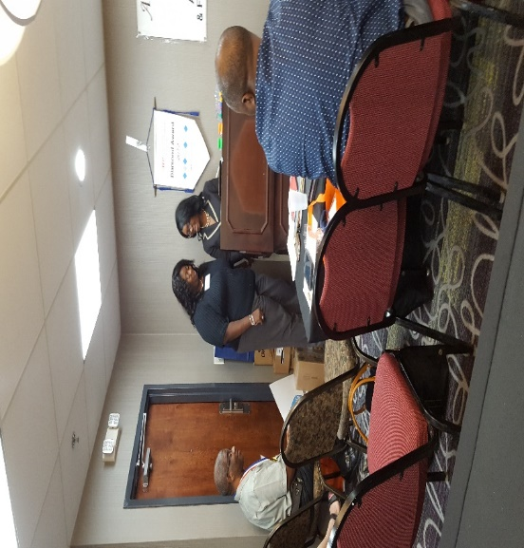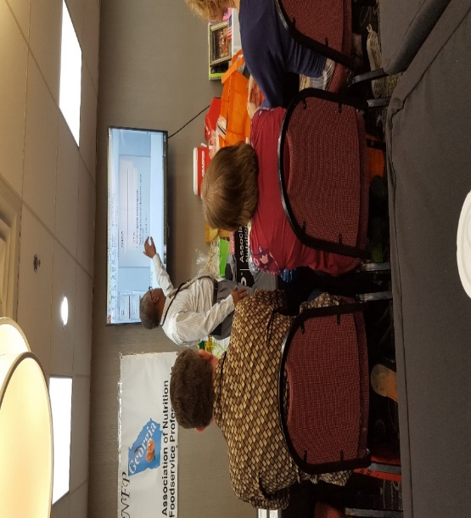

Welcome to our latest newsletter, the second installment this year 2018.

**Teachable Moments**

This year’s spring meeting was held in Columbus Georgia. It was filled with a lot of teachable moments. Each speaker had something to share with the group. The speakers focused on everything from protecting families to the mind diet.

**Hope Harbour**

**Tiarra Sanga:** Our first speaker gave us some insight on helping families during a crisis. She also stressed the need for necessities to help families move forward to a better life. Georgia ANFP assisted in this cause by raising 250.00 and collecting non- perishable donations including toiletries and children’s clothing. Tiarra’s presentation was very moving to the audience.

**CDM-Olympics**

**Ayshia Brown:** Our second speaker focused on getting Student CDM’s prepared for testing by using flash cards, study guides, online review and self-assessment. She also mentioned the breakdown of the current test, which includes 18% nutrition, 20% food service and a combination of miscellaneous topics related to management. At the end of the presentation Ayshia called on a few members from the audience to participate in an Olympic game. The goal of the game was to answer a few questions, participate in a sports challenge and win a medal. It was so much fun team two won three medals the gold, silver and bronze.

**Customer Service**

**Kelvin Tuitt:** Our third speaker and fellow member talked about customer service. He started off with a famous quote from the Ritz Carlton (we are ladies and gentlemen serving ladies and gentlemen) … treating your customers right, it could start with a greeting or by doing something as simple as turning down a bed or serving a special meal to your patient’s. Kelvin also gave his definition of service. (The intangible process where the product meets the customer).

**Leadership & Management**

**Regina St. Clair:** Our fourth speaker talked to fellow members about the difference between Leadership and Management and some of the key traits of both. She also presented two videos, one on the energy bus promoting positive energy and the other a Zig Ziglar favorite about attitude and gratification.

**Med-Fare**

**Stuart Finley:** Our fifth speaker wanted to share with us the importance of using anti-microbial hand wipes and tray covers to help protect resident’s, staff and family members from infections in nursing centers, hospitals and schools. There is a direct focus on HAI’s or (Hospital Acquired Infections) and other infections such as C-DIFF and MRSA. One key component for all of us to focus on is hand washing, it’s the single most important way to reduce infections. Inclosing Stuart gave out samples of Med-Fare anti-microbial wipes and a packet of education and prevention material’s.

**To Clean or Not to Clean**

**Mike Burke:** Our sixth speaker talked about common sanitation practices, with a focus on the flow of food. Mike used the audience to help members solve some of the issues they face in their units, from the delivery of a product to the serving of the meal. Mike asked the audience if they kept maintenance records, for coolers, dish machines and equipment ex: mixers, slicers and blenders. Mike also mentioned that it would be a good idea to mock survey each other, it helps to put a fresh set of eyes on your kitchen, they may see something that you don’t.

**The Mind Diet**

**Kris Knost:** Our final speaker spoke to us about the Mind Diet. This diet is a combination of the Mediterranean and the Dash diets. The Dash diet has been around for a while and focuses on reducing high blood pressure. The base of the Dash diet is everything you would eat normally without the sweets, fats and red meats. This diet has been featured in several studies and the outcomes have been good. On the other hand, the Mediterranean diet is more of a plant base diet and a social experience within itself. When you combine these two diets they could be a catalyst for easing the symptoms of dementia.

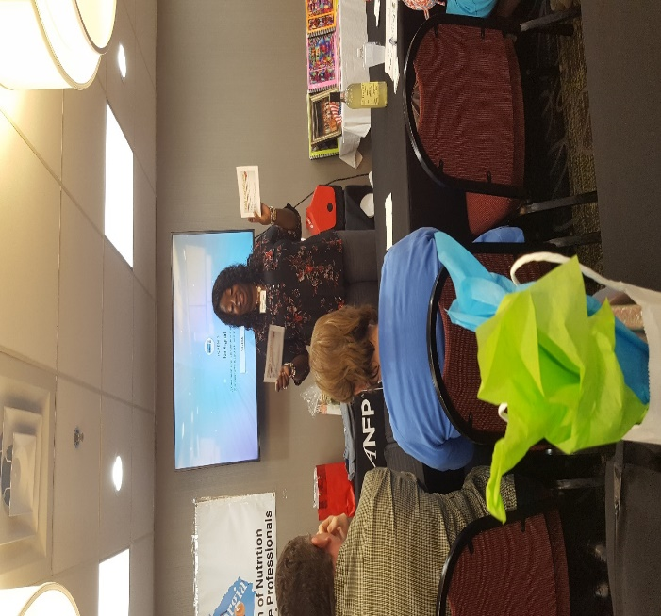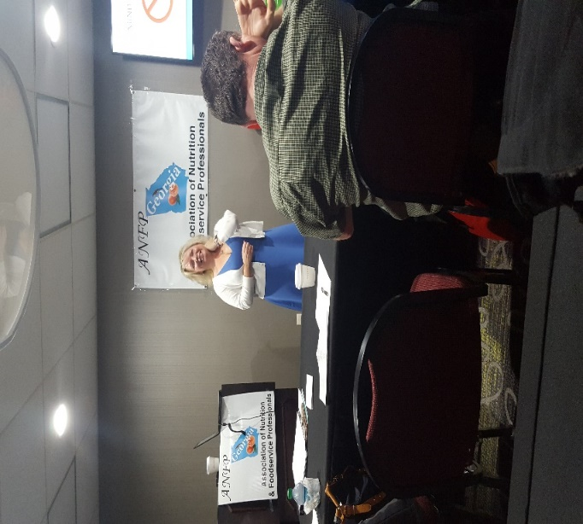

**Spring Meeting attendees**

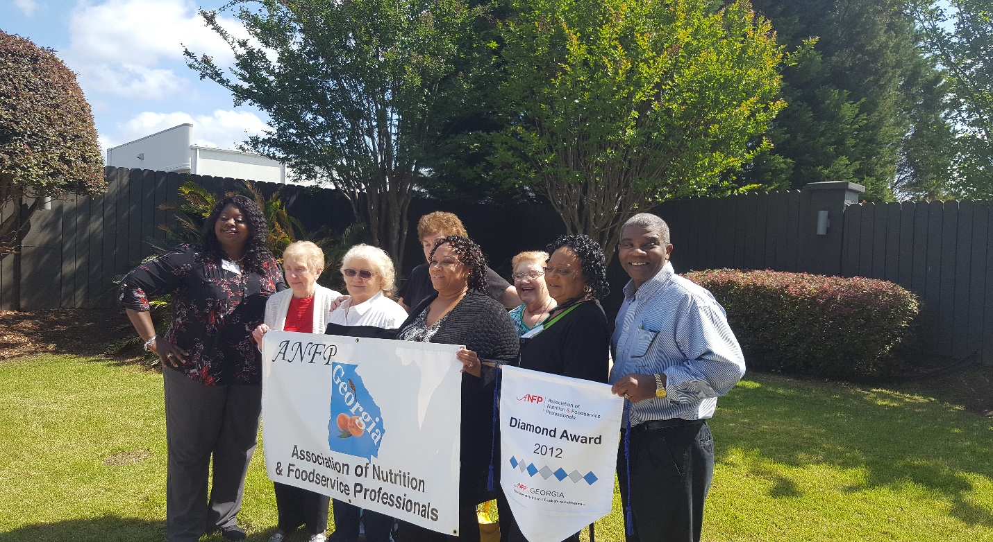We were so lucky to have past and present Presidents attend our spring meeting. From (Left). Lavone Cook, Shirley Singleton, Sharon Clark, Elsie Mills, Geraldine Chandler and Larry Jackson. (Back) Marjorie Widener and Sue Courson.

We also had some new members join us let’s give them a shout out!!

Felix Jones CDM,CFPP

Jennifer Copeland

Patty Davis

David Wieliczki CDM,CFPP

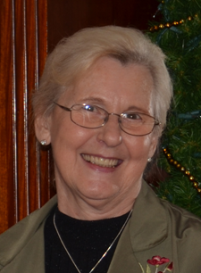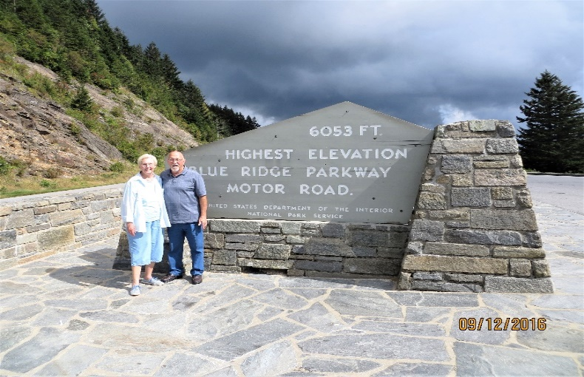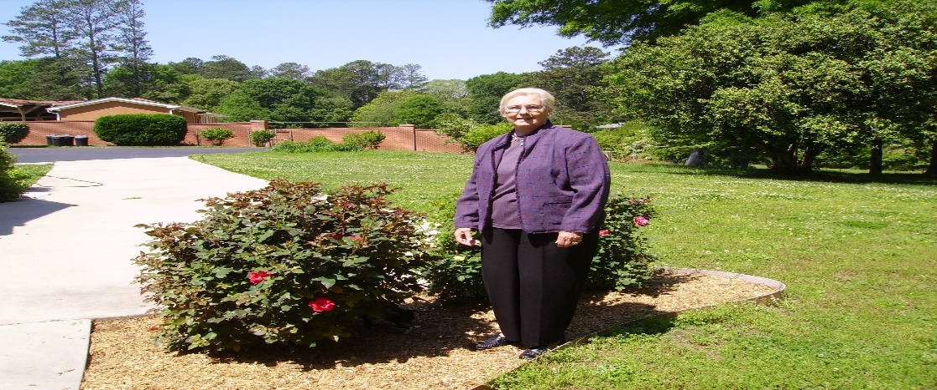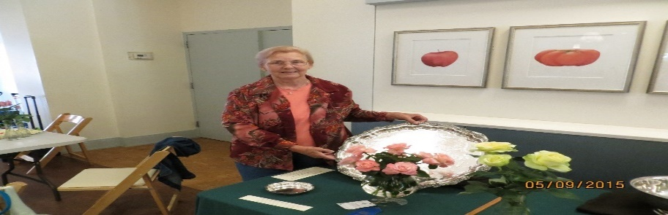 CDM for the

month of May

Emily Landrum CDM, CFPP

Georgia Nutrition Consultants

Emily Landrum has been in the food service industry for about 50 years. Emily and her Husband Jim operated a 200-seat restaurant on Hatteras Island, the Outer Banks of North Carolina for about 25 years.

While living in on the Island Emily was very active in community affairs including volunteering as an EMT, working as a board member on two separated entities, the Dare County Chamber of Commerce and the Dare County Tourist Bureau. Emily also supported the Meals on Wheels program and the elderly citizens of Hatteras Island.

Emily and her husband left Hatteras Island in the early nineties. In 1993 Emily joined the Piedmont Hospital food service department as a catering coordinator, she was responsible for overseeing several hospital and off campus functions with an operational budget of 250,000 a year.

In 1995 Emily was promoted to a Dietary Manager for Piedmont Hospital. Emily responsibilities included managing a large production and sanitation staff of at least 50 employees.

In 1997 Emily became interested in getting her CDM, while she was a student of DMA (ANFP) she attended her first national meeting in Nashville Tennessee. After a few hard months of studying Emily completed the University of Georgia’s Dietary Managers Program in 1997. She became a certified Dietary Manager in 1998. Emily worked for Piedmont Hospital for over 13 years until her retirement, in 2006 Emily took a job with Nutrition Consultants with whom she is still affiliated.

Emily continues to be a dedicated participate in ANFP. According to Emily the meetings are a wonderful place to make life long friends, network and keep update to date with the latest trends in food service.

Emily has held several positions as a member of the GA-ANFP. Emily has been President of the Chapter, Newsletter Editor and spokesperson. Emily also served on the National board of Directors, The National Certifying Board and the Future Leaders Training Workshop. Emily has also been a Serv-Safe Proctor and speaker at many of the GA-ANFP meetings.

Emily enjoys gardening and growing flowers in fact Emily and her husband has won several awards for their beautiful roses including the Silver Plate award. Emily also loves traveling, spending time with her family and attending ANFP meetings in her State and Nationally as well.

**Current member count GA-ANFP**

|  |  |  |  |
| --- | --- | --- | --- |
| **Allied Professional** | **19** | **0** | **19** |
| **Pre-Professional** | **28** | **0** | **28** |
| **Professional** | **12** | **219** | **231** |
| **Retired Professional** | **0** | **3** | **3** |
|  | **59** | **222** | **281** |

|  |  |  |  |
| --- | --- | --- | --- |
| **From the President’s Desk…** |  |  |  |

Greetings GA ANFP Members!

Thanks for a GREAT Spring meeting and a wonderful opportunity to learn and network with GA ANFP members, the community and the speakers…. We had a WONDERFUL three-day conference in beautiful Columbus, Ga! Thanks to all the board members for their hard work and commitment to move this great chapter forward!

Thanks to everyone, we have achieved the following 2018 goals which was set for our State:

* Organizing a State Chapter Community Service Event – ***Central Ga Food Bank, Macon, GA Donation of 250lbs of food during the Fall conference and Meal Prep for Ronald MacDonald House in Augusta, GA***
* Increasing Membership and Public Exposure – ***Increased members vs. prior year. Conducted a presentation at*** ***Ethica Managers Meeting for over 100 managers about ANFP and the benefits of being a member from the state and national level. Amy Fraser became our Webmaster and revamped our Facebook Page for exposure (CDM of the Month feature) and Regina St. Clair is providing exposure thru email and newsletters.***

***Our state will be receiving the following awards at the ACE conference in Orlando: Gold State Achievement, Communication, Government Affair, and Membership award. We are also a nominee for the DIAMOND AWARD! Larry Jackson and Amy Fraser will also be receiving ACE awards in Orlando!***

***Ms. Sharon Clark and the Ga Chapter were selected to receive the donation (up to $1000) for the breakfast/lunch of our next chapter meeting.***

***CONGRATULATIONS to a job well done by ALL! I’m so proud of GA ANFP!*** The ballots are all in and our new Executive Board members for the 2018 – 2020 Executive Board positions are listed in the newsletter.

Larry Jackson and Elsie Mills are already planning our fall meeting for Macon.

REMEMBER… Our legislative duty is to get in touch with your congressman and Administrators to gather their support for the Safe Food for Seniors Bill and invitation to our chapter meetings.

As many of you know, I will be closing my chapter as your President this year. I have truly enjoyed this journey and know that your upcoming leaders will continue to position GA ANFP members as “experts in foodservice management” and put your needs first. There is still work to be done in Georgia and I have full faith we will continue to move forward and progress!

Thanks for all you do!

Lavone Cook, CDM, CFPP

Georgia ANFP President

Happy spring Members,

I want to give a big “Thank You” to all the members that came to Columbus for our spring conference. Thank you to all our speakers and the great time that the board presented to the members. I would like to give special thank you to all the vendors that contributed to the gift bags. They were great, and we never got hungry while listening to some very informative sessions. I am so thankful for the group of individuals that make up our board. We never could have pulled off a conference without everyone’s help.

Now that is that time again that a new board is getting ready to take over. We have some very talented members that are coming in to continue to work hard to represent all of GAANFP. I know we are going to continue to represent Georgia in ways that can’t be imagined. I could not end this year without saying a few words about our President Lavone Cook. Lavone is a very dedicated member of our board that has worked very hard for this organization. She was always on top of her game when it comes to Georgia ANFP. She’s always willing to lend a helping hand when needed and she will pull you back if she feels things getting out of hand. She’s a strong woman and friend that I am very proud to have in my corner. Now that I will be coming in a President; Lavone has set high expectations and I’ve got to work even harder to follow in her footsteps.

Now it’s time to get ready for our Fall Meeting and Food Expo. We are still looking for vendors to be a part of our Food Expo, and volunteers to work on committees. It takes all of us working together to make our organization bigger and better.

Please continue to stay healthy and happy. I look forward to seeing you all in the fall.

Sincerely,

Elsie Mills CDM, CFPP

President-elect

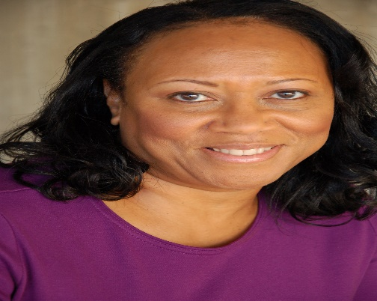

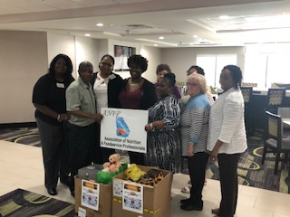

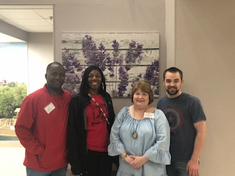

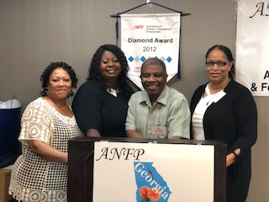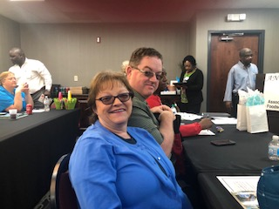**PHOTOS**

**A note from your Secretary**

 Hi All,

If you missed our Spring Meeting in Columbus, you missed a very informative meeting.

We had some great speakers, 3 first time members and one member from South Carolina we were pleased to have her visit with us. We hope they all felt welcome. We had 50 members registered for our meeting and out of that 50, 3 was unable to attend. We were also very fortunate to have 9 Past -Presidents in our presence.

We had a great raffle/ drawing, including a 5 and 10-dollar raffle. There were several prizes up for grabs including a 2-night stay at the Laquita Inn in Columbus and 2 certificates to a GA-ANFP meeting. Sue Courson won the 2-night stay at Laquita Inn, Wanda Paulk and Alphonso Wisseh won the free registration certificates.

Congratulations to our ACE winners and our ANFP Volunteer winner.

Larry Jackson and Amy Fraser won the ACE awards Larry for Distinguished Service and Amy’s Hospital won for being an advocate from ANFP. Sharon Clark won a prize for the GA-ANFP, she will be given up to 500.00 to help provide a meal at our next meeting.

Finally, it was time to vote for our President-Elect, Treasurer, and Secretary. Those present voted on site and afterwards Regina sent out an e-mail blast to our members to give them the chance to vote.

I would to personally thank all the members who contributed goodies for our very nice goodie bags. It was truly an enjoyable meeting.

Take care and I hope to see you all in the fall

Sharon Clark

Secretary

Georgia ANFP

**The Votes are in GA-ANFP!!**

First, we would like to thank all the members who participated in the voting process…

It’s with great pleasure to announce the Georgia ANFP 2019-2020 Board Members…

*President- Elect: Regina St. Clair*

*Treasurer: Geraldine Chandler*

*Secretary: Sharon Clark*

**A special note!!**

**Members we always conduct a board meeting prior to every meeting we hold.**

**The spring meeting (2018) was attended & audited by Sue Courson and Geraldine Vandergriff.**

**both ladies were given the opportunity to hear to the board reports,**

**committee reports, new and old business. It is imperative that we remain**

**transparent to our members… if anyone is interested in attending our next board meeting please let a board member know.**

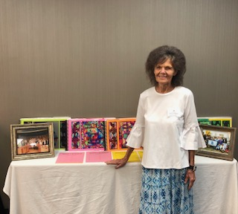

**We work for you and your input is very important to us.**

The call for **Georgia ANFP** volunteers is open, take this great opportunity to gain further experience, expand and grow in your career and make an impact nationally, in shaping the future of ANFP and the foodservice industry. ANFP is a member-based organization; the association grows in credibility and reputation because of your volunteer input.

Volunteering is not only fun, it is also rewarding and benefits you professionally and personally. As a volunteer, you can: gain leadership skills that transfer to your professional and personal lives, become an "insider" and foster teamwork, make new friends, and build your resume by contributing to industry issues.

To volunteer, please complete the following information and return to **Lavone Cook** via Email

Name: ____________________________________________________________________

Email address: _____________________________________________________________

Phone: _______________________ Best time to reach you: 󠆽Morning 󠆽󠅲 Afternoon 󠅲󠅲 Evening 󠅲󠅲

If you have questions, please contact **Lavone Cook** via e-mail at lavonecook@att.net or via phone at **706.726.8865.**

Sincerely,

Lavone Cook

President GA-ANFP

|  |  |  |  |  |  |  |  |  |  |  |  |  |  |  |  |  |  |  |  |  |  |  |  |  |  |  |  |  |  |  |  |  |  |  |  |  |  |  |  |  |  |  |  |  |  |  |  |  |  |  |  |  |  |  |  |  |  |  |
| --- | --- | --- | --- | --- | --- | --- | --- | --- | --- | --- | --- | --- | --- | --- | --- | --- | --- | --- | --- | --- | --- | --- | --- | --- | --- | --- | --- | --- | --- | --- | --- | --- | --- | --- | --- | --- | --- | --- | --- | --- | --- | --- | --- | --- | --- | --- | --- | --- | --- | --- | --- | --- | --- | --- | --- | --- | --- | --- |
| **Safe Food for Seniors**  Members we are counting on you to keep the conversation going on the Safe Food for Seniors Act, please reach out to a member of your county seat, congressman or woman to let them know how important it is to have a Dietary Manager (Certified) and in charge of the food services for SNF, LTC, or assisted living facilities in the State Georgia.   |  |  |  |  |  |  |  |  |  |  |  |  |  |  |  |  |  |  |  |  |  |  |  |  |  |  |  |  |  |  |  |  |  |  |  |  |  |  |  |  |  |  |  |  |  |  |  |  |  |  |  |  |  |  |  |  |  |  | | --- | --- | --- | --- | --- | --- | --- | --- | --- | --- | --- | --- | --- | --- | --- | --- | --- | --- | --- | --- | --- | --- | --- | --- | --- | --- | --- | --- | --- | --- | --- | --- | --- | --- | --- | --- | --- | --- | --- | --- | --- | --- | --- | --- | --- | --- | --- | --- | --- | --- | --- | --- | --- | --- | --- | --- | --- | --- | | |  |  |  |  |  |  |  |  |  |  |  |  |  |  |  |  |  |  |  |  |  |  |  |  |  |  |  |  |  |  |  |  |  |  |  |  |  |  |  |  |  |  |  |  |  |  |  |  |  |  |  |  |  |  |  |  |  | | --- | --- | --- | --- | --- | --- | --- | --- | --- | --- | --- | --- | --- | --- | --- | --- | --- | --- | --- | --- | --- | --- | --- | --- | --- | --- | --- | --- | --- | --- | --- | --- | --- | --- | --- | --- | --- | --- | --- | --- | --- | --- | --- | --- | --- | --- | --- | --- | --- | --- | --- | --- | --- | --- | --- | --- | --- | | |  |  |  |  |  |  |  |  |  |  |  |  |  |  |  |  |  |  |  |  |  |  |  |  |  |  |  |  |  |  |  |  |  |  |  |  |  |  |  |  |  |  |  |  |  |  |  |  |  |  |  |  |  |  |  |  | | --- | --- | --- | --- | --- | --- | --- | --- | --- | --- | --- | --- | --- | --- | --- | --- | --- | --- | --- | --- | --- | --- | --- | --- | --- | --- | --- | --- | --- | --- | --- | --- | --- | --- | --- | --- | --- | --- | --- | --- | --- | --- | --- | --- | --- | --- | --- | --- | --- | --- | --- | --- | --- | --- | --- | --- | | **Georgia ANFP - Current Officers**   |  | | --- | |  | | **President** | [**Cook, Lavone**](mailto:lavonecook@att.net) PO Box 5151, Augusta, GA 30916 | (706) 726-8865 | |  |  |  | | **President Elect** | [**Mills, Elsie**](mailto:elsielee@bellsouth.net) 278 Village Dr. McDonough, GA 30253 | (770) 898-1459 | |  |  |  | | **Secretary** | [**Clark, Sharon**](mailto:sharonclark6@yahoo.com) 413 N Baker St, Glennville, GA 30427-2433 | (912) 237-1426 | |  |  |  | | **Treasurer** | [**Chandler, Geraldine**](mailto:chandler30233@yahoo.com) 111 Doc Barkley Rd, Jackson, GA 30233 | (770) 775-7861 | |  |  |  | | **Spokesperson** | [**Alexander, Kellie**](mailto:kdalexander@magnoliamanor.com) 1307 Lovers Ln Rd, Dawson, GA 31742 | (229) 854-0060 | |  |  |  | | **Newsletter Editor** | [**St Clair, Regina**](mailto:yamao@bellsouth.net) 1068 Abercorn Way, Douglasville, GA 30134 | (770) 827 6076 | |  |  |  | | **Webmaster** | [**Fraser, Amy**](mailto:amy.fraser@tiftregional.com) 198 Lower Brookfield RD Tifton, GA 31794-8915 | (229) 402-0897 | |  |  |  | | **Travel Chairperson** | [**Jackson, Larry**](mailto:jackson3705@bellsouth.net) 196 Buttercup Ln, Americus, GA 31709 | (229) 591-0586 | |  |  |  | | **Finance Committee** | [**Tuitt, Kelvin**](mailto:kelvintuitt@me.com) 5208 Miller Woods Trail, Decatur, GA 30035 | (404) 862-3253 | |  | | | | | | |
| |  |  | | --- | --- | | |  | | --- | |  | | | |

# 



[This Photo](http://golibrarians.wordpress.com/2011/08/11/facebook-and-branding/) by Unknown Author is licensed under [CC BY-NC-ND](https://creativecommons.org/licenses/by-nc-nd/3.0/)



